**TITLE: “SMART ROUTE OPTIMIZATION MINIMIZE TRAVEL”**

**Introduction**

Route optimization is the process of determining the most efficient path or sequence of paths to achieve a specific goal, such as minimizing travel time or cost. In the context of AI and Machine Learning (ML), route optimization can be enhanced using advanced algorithms and models to solve complex routing problems. Python, with its extensive libraries and tools, is a powerful language for implementing these solutions.

**Objectives**

* **Develop a route optimization model** using AI and ML techniques to find the most efficient paths for various applications.
* **Utilize Python libraries** to implement algorithms and models for solving routing problems.
* **Evaluate the performance** of the developed model against traditional methods.

**Use Cases**

* **Transportation and Logistics:** Optimizing delivery routes for trucks to reduce fuel consumption and improve efficiency.
* **Public Transportation:** Improving bus and train schedules to minimize waiting times and operational costs.
* **Travel Planning:** Helping individuals plan the most efficient travel routes for vacations or business trips.

**Approach**

1. **Data Collection**

**Geographic Data:** Collect data on road networks, traffic patterns, and geographic

sources such as Open Street Map or Google Maps API.

**Historical Data:** Gather historical data on travel times, traffic conditions.

1. **Preprocessing**

**Data Cleaning:** Handle missing values, outliers, and inconsistencies in the data.

**Algorithm Selection**

**Classical Algorithms**

* **Algorithm:** Finds the shortest path between nodes in a graph.
* **A Search Algorithm***:* An extension of Dijkstra’s Algorithm that uses heuristics to improve efficiency.

**Machine Learning Approaches**

* **Reinforcement Learning:** Use algorithms like Q-learning or Deep Q-Networks (DQN) to learn optimal routing strategies through trial and error.

**Implementation**

**Python Libraries**

* **NUMPY:** working with graphs and implementing classical algorithms.
* **Google OR-Tools:** Provides optimization tools for routing problems.
* **Integration:** Combine algorithms with real-time data sources to provide dynamic route optimization.

**Evaluation**

* **Performance Metrics:** Assess the efficiency of the optimized routes using metrics such as total travel time, cost, and distance.
* **Comparative Analysis:** Compare the results with traditional route planning methods to evaluate improvements.

**Deployment**

* **API Integration:** Create APIs to integrate the route optimization model with existing systems or applications.

**5. Expected Outcomes**

* **. Efficient Routes:** The model should provide optimized routes that minimize travel
* **. Performance Improvement:** Demonstrated improvements over traditional route
* optimization
* **. User-Friendly Application:** A practical tool for end-users to easily access and benefit from route optimization.

**Challenges**

* **Data Quality:** Ensuring high-quality and up-to-date geographic and traffic data.
* **Scalability:** Handling large-scale problems and ensuring that the model performs efficiently with increasing data size.
* **Real-Time Processing:** Incorporating real-time data and making adjustments to routes on the fly.

**Conclusion**

Route optimization using AI and ML with Python offers significant potential for improving efficiency and reducing costs in various applications. By leveraging Python’s powerful libraries and advanced algorithms, it is possible to develop robust models that enhance route planning and decision-making. This approach not only provides practical solutions for users but also contributes to advancements in the field of intelligent transportation systems.

**Input:**

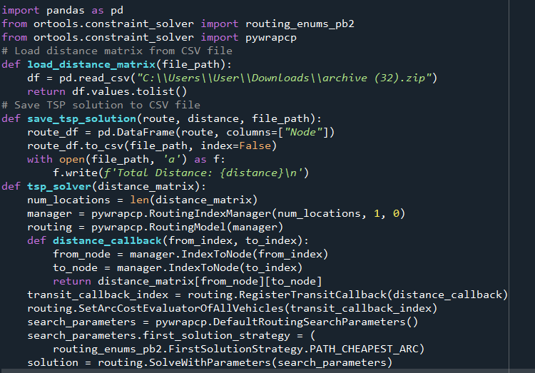

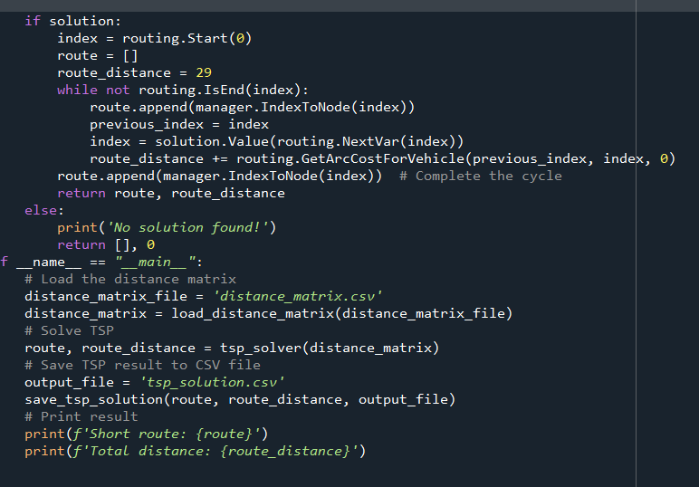

**Output:**

